Affiliated to Pokhara University

**POKHARA ENGINEERING COLLEGE**

Phirke, Pokhara-8



**A**

**Project Proposal on**

**Typing Accuracy Check**

**Submitted by :**

Anurag Ale (22070446)

Britant Shrestha (22070449)

Manish Shrestha (22070452)

Ranjana Dhakal (22070457)

**Submitted to :**

Research Management Cell

Pokhara Engineering College

2025

**Table of Contents**

**1. Introduction**

1.1 Background…………………………………..………………………………………………………..1

1.2 Statement of Problems……….…………………………………………………………………..……1

1.3 Objective…………..……………………………………………………………………………..…....1

1.4 Scope of Project……………………………………………………….……....………………………1

1.5 Limitations……………………………………………………….…………....………………………2

**2. Literature Review**………………………………………………………………..…....………………………3

**3. Methodology**

3.1 Approach…………………………….………………………………………...……………………...4

3.2 Flowchart…………………………………………………………………...…………………...…….5

**4. Project Schedule**…………………………………….………...……………………...……………………….6

**5. Expected Outcomes**……………………………………………………….……….….……………………....7

**References**…………………………...……………………………………………………………………..….....8

**Chapter 1: Introduction**

* 1. **Background**

In today's digital age, typing speed and accuracy are essential skills for students, professionals, and casual users alike. A Type Speed and Accuracy Tester application helps users measure and improve their typing efficiency. "KeyDash" is a web-based application designed to evaluate typing speed in words per minute WPM) and accuracy while providing a user-friendly interface. The project leverages modern web technologies like HTML, Tailwindcss, JavaScript, and React.js to create an interactive and responsive tool.

* 1. **Statement of Problem**

Existing typing test applications often suffer from outdated designs, limited functionality, and a lack of engaging features. Many fail to provide real-time feedback on essential performance metrics such as words per minute (WPM), typing accuracy, and error counts. Additionally, the user interfaces are frequently unintuitive and visually unappealing, diminishing the overall user experience. There is also limited support for diverse typing modes, such as endless typing, quote typing, and paragraph typing, which are crucial for varied practice. Furthermore, most applications do not offer integration with platforms like GitHub for version control and collaboration, nor do they incorporate entertainment elements that could enhance user engagement**. KeyDash** seeks to address these shortcomings by delivering a modern, feature-rich typing application that emphasizes real-time performance tracking, a user-friendly and attractive interface, multiple typing modes, GitHub integration, and an enjoyable interactive experience.

* 1. **Objective**

The primary objectives of KeyDash are:

* To develop a responsive and interactive typing speed tester using HTML, Tailwindcss, JavaScript, and React.js.
* To provide real-time feedback on typing speed and accuracy and implement user authentication for saving and comparing past results.
  1. **Scope of Project**
* Improving Typing Skills: Users can practice typing with randomized text snippets, helping them enhance their speed and accuracy over time.
* Ergonomic Typing Guidance: By providing real-time tips on which finger should press each key, the app promotes proper typing techniques, reducing strain and increasing efficiency.
* Educational & ProfessionalUse: Students, professionals, and casual users can benefit from structured typing practice, which is essential for productivity in academic and work environments.
  1. **Limitations**
* Limited to web browsers (no standalone mobile app).
* Advanced features like multiplayer mode or AI-based feedback are out of scope.
* Can only do English Language.

**Chapter 2: Literature Review**

We have gone through several research papers and have found their work which are presented in this chapter.

A Type Speed and Accuracy Tester application, such as KeyDash, helps users measure and improve their typing efficiency, a crucial skill in today's digital age for students, professionals, and casual users. KeyDash is a web-based application designed to evaluate typing speed in words per minute (WPM) and accuracy with a user-friendly interface. It utilizes modern web technologies like HTML, Tailwindcss, JavaScript, and React.js to create an interactive and responsive tool.

Existing typing test applications often have outdated designs, limited functionality, and a lack of engaging features. Many fail to provide real-time feedback on key performance metrics like WPM, typing accuracy, and error counts. Additionally, their user interfaces are frequently unintuitive and visually unappealing, which diminishes the overall user experience. There is also limited support for diverse typing modes such as endless typing, quote typing, and paragraph typing, which are essential for varied practice. Furthermore, most applications lack integration with platforms like GitHub for version control and collaboration, and they often do not incorporate entertainment elements to enhance user engagement.

KeyDash aims to address these shortcomings by delivering a modern, feature-rich typing application that focuses on real-time performance tracking, a user-friendly and attractive interface, multiple typing modes, GitHub integration, and an enjoyable interactive experience.

Research highlights the significance of typing speed and accuracy. Rogers and Monsell (1995) found that increased typing speeds reduce task completion time in computer-based processes. Karat et al. (1999) discovered that better accuracy reduces cognitive strain, allowing users to focus on content rather than mechanics. More recent research (Chen et al., 2021) emphasizes the relevance of adaptive feedback in increasing skill development, a feature KeyDash intends to incorporate.

Traditional typing platforms like 10FastFingers assess WPM and accuracy using standardized tests but lack personalized feedback. Typing Master provides structured training but uses static exercises without real-time modification. Limitations of current tools include fixed difficulty that doesn't adapt to user skill levels, limited analytics that fail to offer detailed error analysis, and a lack of gamification features such as leaderboards or achievements.

**Chapter 3: Methodology**

**3.1 Approach**

* Agile Development: Iterative sprints with GitHub for task tracking.
* Tech Stack:
* Frontend: React.js (hooks, components), Tailwindcss for styling.
* Version Control: GitHub (branches, pull requests).
* Saving system: Firebase

**3.2 Flowchart**

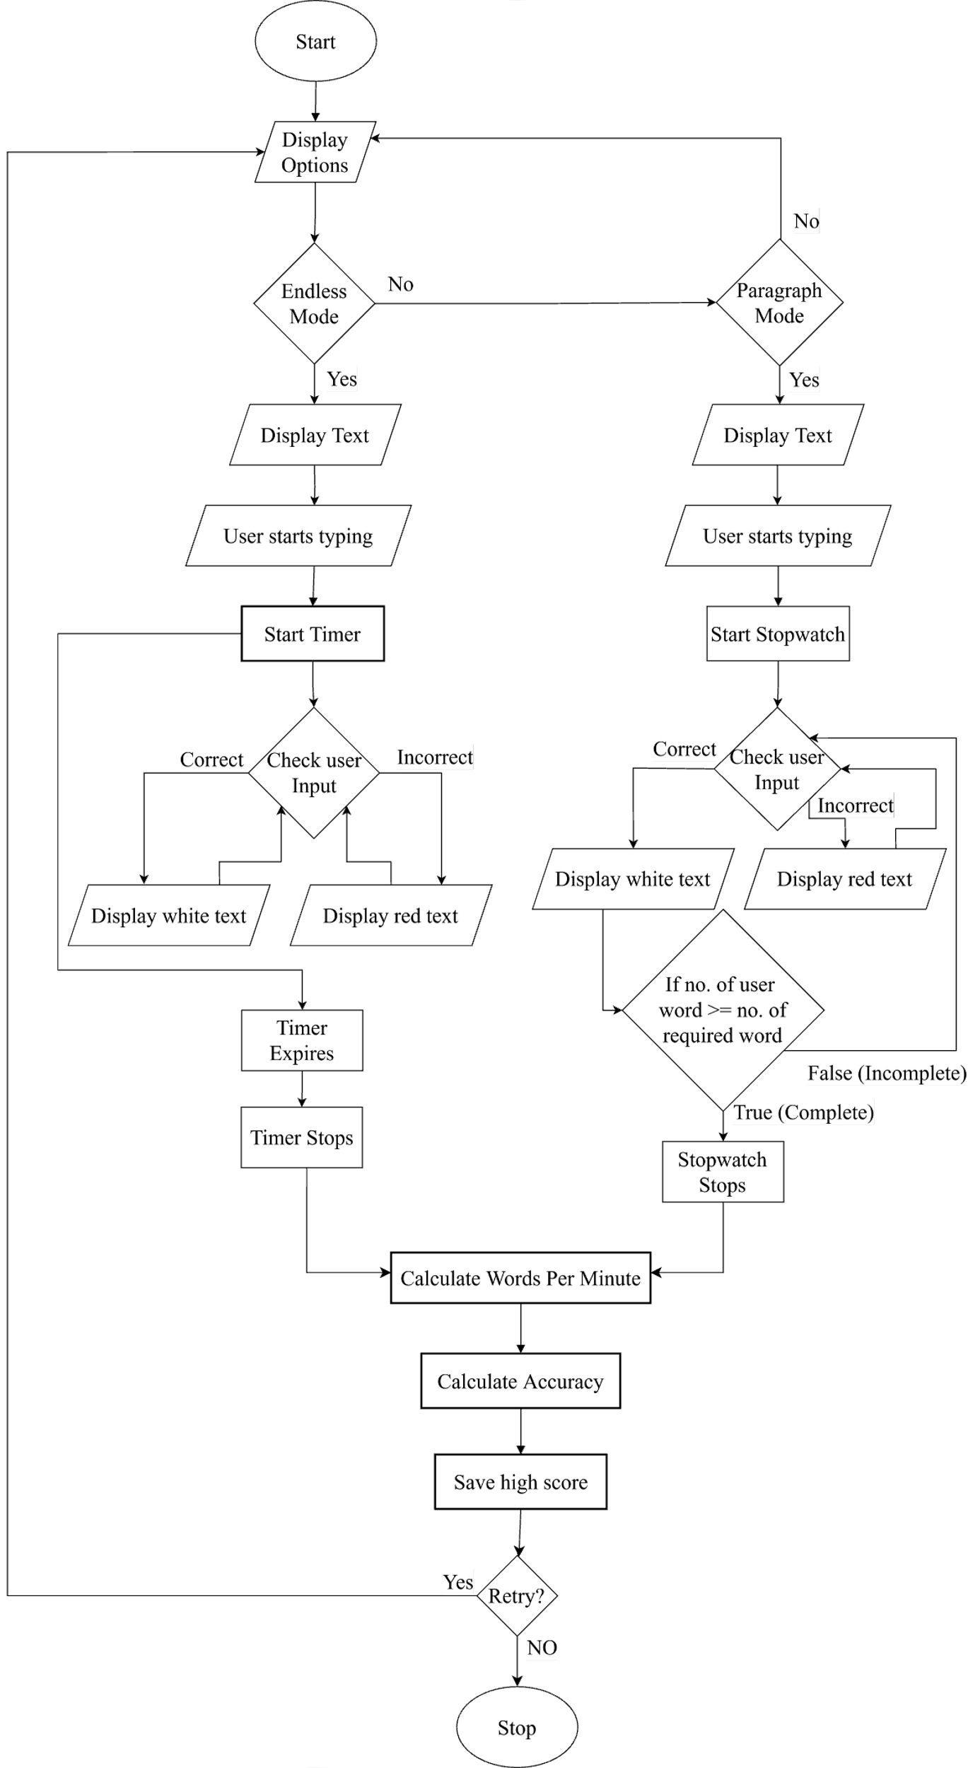

**Chapter 4: Project Schedule**

**Gantt Chart**:

|  |  |  |  |  |  |  |
| --- | --- | --- | --- | --- | --- | --- |
| **Steps** | **Week 1-2** | **Week 3-4** | **Week 5-8** | **Week 9-10** | **Week 11-12** | **Week 13-14** |
| Requirements Gathering |  |  |  |  |  |  |
| Planning |  |  |  |  |  |  |
| Development |  |  |  |  |  |  |
| Testing |  |  |  |  |  |  |
| Deployment |  |  |  |  |  |  |
| Maintenance |  |  |  |  |  |  |
| Documentation |  |  |  |  |  |  |

**Chapter 5: Expected Outcomes**

* Typing Performance Metrics:
* Accurately measure user’s typing speed (WPM) and error rates with real-time feedback.
* A fully functional web-based typing tester built with React.js, featuring:
* Timed tests with randomized text snippets.
* Real-time WPM/accuracy dashboards.
* **Modular Design**:
* Lay groundwork for future features (e.g., multiplayer mode, AI-driven feedback) via a scalable React.js architecture.
* Saving System:
* Enable progress tracking with saved history and personalized insights.

**References:**

10FastFingers. (n.d.). 10FastFingers. <https://10fastfingers.com>

Typeshala. (n.d.). Typeshala. <http://typeshala.shresthasushil.com.np/>

Chen, Y., Chen, Y., & Huang, Y. (2021). Adaptive feedback systems and their impact on learning performance: A meta-analysis. Computers & Education, 174, 104309. https://doi.org/10.1016/j.compedu.2021.104309

Deterding, S., Dixon, D., Khaled, R., & Nacke, L. (2011). Gamification: Toward a definition. In CHI 2011 Conference on Human Factors in Computing Systems (pp. 12–15). <https://doi.org/10.1145/1979742.1979575>

Rogers, R. D., & Monsell, S. (1995). Costs of a predictable switch between simple cognitive tasks. Journal of Experimental Psychology: General, 124(2), 207–231.

Zhang, L., & Sun, T. (2023). Real-time feedback systems in typing tutors: A WebSocket-based approach. Journal of Educational Technology & Society, 26(1), 89–102. <https://doi.org/10.2307/jeductechsoci.26.1.89>